# AllocateMate: An R package for mate allocation

Matthew Hamilton

April 2021

# Mate allocation in WorldFish genetic improvement programs

WorldFish manages multiple family-based genetic improvement programs involving tilapia and carp species (Charo-Karisa et al., 2020; Hamilton et al., 2019a; Hamilton et al., 2019b; Hamilton et al., 2021; Hamzah et al., 2014). In such family-based genetic improvement programs, mate allocation is the process of allocating parents to mating pairs to generate required full- and/or half-sibling families. Mate allocation is can be undertaken to:

* control inbreeding in the next generation, by reducing the Wright’s inbreeding coefficient (**F**) in progeny (Wright, 1922); and/or
* increase the between-family component of the additive-genetic variance in the next generation, by enforcing assortative mating (Saura et al., 2017).

# AllocateMate package

AllocateMate is a R package (R Core Team, 2020) comprised of two primary functions: *allocate.mate.ped* and *allocate.mate.H*. These functions allocate parents to mating pairs (i.e. generate a mating list) based on genetic relationships provided in the form a pedigree file – using *allocate.mate.ped* – or a relationship matrix – using *allocate.mate.H*. Using these functions, mating lists can be generated:

* to minimise the average **F** of progeny (Wright, 1922), using a linear programing approach (Berkelaar, 2020) and assuming equal numbers of progeny in each full-sib family, or
* according to assortative mating principles – that is, by allocating sires of high EBVs with dams of high EBVs, and *vice versa* (Saura et al., 2017), with a constraint on the acceptable maximum level of **F** in progeny.

The *allocate.mate.ped* and *allocate.mate.H* functionsare detailed in Appendix 1 and Appendix 2.

# Installing AllocateMate

# AllocateMate Version 1.0 is available at <https://github.com/mghamilton/AllocateMate> or for download as a .tar.gz ‘source file’ (provide link). To install the package from the .tar.gz source file:

# use the *install.packages* function in R – install.packages(*path-to-source-file*, repos = NULL, type = "source"); or

# within R studio, go to Tools -> Install Packages and then set ‘Install From’ to ‘Package Archive File (.zip; .tar.gz)’ before browsing to find the downloaded .tar.gz file.

# References

Berkelaar, M., 2020. Package ‘lpSolve’. Version 5.6.15. CRAN. <https://cran.uib.no/web/packages/lpSolve/lpSolve.pdf>.

Charo-Karisa, H., Ali, S., Marijani, E., Ibrahim, N.A., Trinh, T.Q., Chadag, M.V., Benzie, J.A., 2020. Genetic parameters for black spot disease (diplopstomiasis) caused by Uvulifer sp. infection in Nile tilapia (Oreochromis niloticus L.). Aquaculture, 736039

Hamilton, M.G., Mekkawy, W., Benzie, J.A.H., 2019a. Sibship assignment to the founders of a Bangladeshi *Catla catla* breeding population. Genetics Selection Evolution. 51, 17. <https://doi.org/10.1186/s12711-019-0454-x>

Hamilton, M.G., Mekkawy, W., Kilian, A., Benzie, J.A.H., 2019b. Single Nucleotide Polymorphisms (SNPs) reveal sibship among founders of a Bangladeshi rohu (*Labeo rohita*) breeding population. Front Genet. 10. <https://doi.org/10.3389/fgene.2019.00597>

Hamilton, M.G., Mekkawy, W., Barman, B.K., Alam, M.B., Karim, M., Benzie, J.A.H., 2021. Genetic relationships among founders of a silver carp (*Hypophthalmichthys molitrix*) genetic improvement program in Bangladesh. Aquaculture, 736715. <https://doi.org/https://doi.org/10.1016/j.aquaculture.2021.736715>

Hamzah, A., Ponzoni, R.W., Nguyen, N.H., Khaw, H.L., Yee, H.Y., Mohd Nor, S.A., 2014. Performance of the Genetically Improved Farmed Tilapia (GIFT) strain over ten generations of selection in Malaysia. Pertanika J Trop Agric Sci. 37, 411-429

R Core Team, 2020. R: A language and environment for statistical computing. R Foundation for Statistical Computing, Vienna, Austria.

Saura, M., Villanueva, B., Fernández, J., Toro, M.A., 2017. Effect of assortative mating on genetic gain and inbreeding in aquaculture selective breeding programs. Aquaculture. 472, 30-37

Wright, S., 1922. Coefficients of inbreeding and relationship. Am Nat. 56, 330-338

# Appendix 1. allocate.mate.ped function help

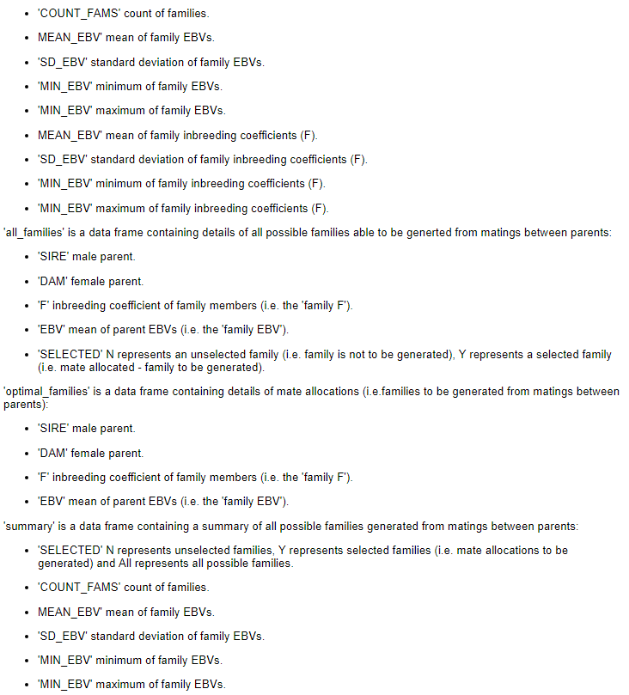

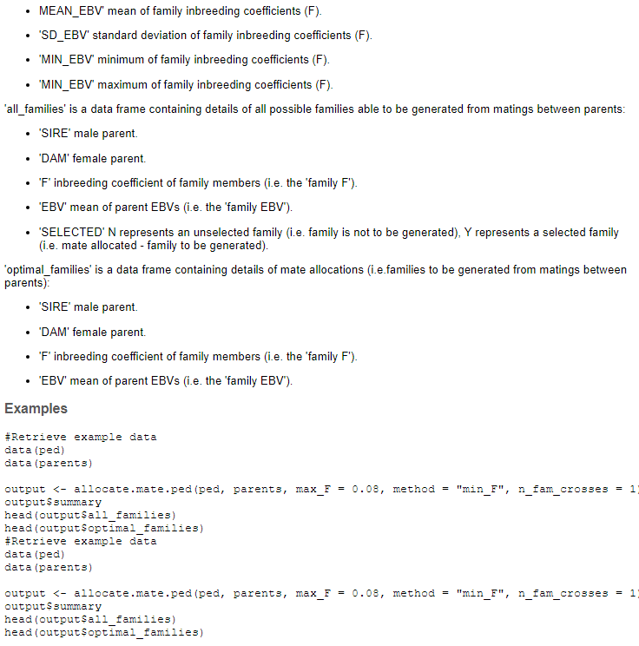



# Appendex 2. allocate.mate.H function help

